

On May 16, 2009, Stephen Wolfram launched one of the most ambitious and long term projects undertaken by him – **Wolfram|Alpha (**[http://www.wolframalpha.com](http://www.wolframalpha.com/)). The answer engine is based on **natural language processing**, which consists of a large library of algorithms to help it understand what the user wants to know and give the answer accordingly. It is increasingly becoming the world’s most reliable source for instant expert knowledge and computation.

Enter Stephen Wolfram.

A British Scientist and mathematician, he is the Chief Designer of Wolfram|Alpha, or the “**Computational Knowledge Engine**”, as he calls it. He published his first physics paper at 15, received a Ph.D. in particle physics from Caltech at 20 and won one of the first MacArthur Awards at 21.

The main aim of this engine is to make all the systematic knowledge immediately computable by anyone. Just enter a question or calculation, and Wolfram|Alpha uses the built-in algorithms and huge collection of growing data to give the answer.

It’s used to power some searches in the ***Microsoft Bing***. Also **25%** of the queries of Wolfram|Alpha come from the Apple iPhone 4S exclusive, ***Siri*.** On Wolfram|Alpha’s 2nd anniversary in 2011, Stephen Wolfram declared that it could understand 95% of all the queries, which is excellent knowing the fact that it is bound by algorithms and facts.

The thing that you should know about Wolfram|Alpha is that it is neither a Wikipedia/Google killer nor does it aim to be. So typing in “Apple” or “Microsoft” would not give a page about their history as expected with Wikipedia but a plethora of statistics and graphs, stock values, performance comparisons and more. Also, typing in “How to change my desktop wallpaper?” and similar questions will fetch you no results for obvious reasons.

Its knowledge bank is impressive, from complex mathematical calculations that would freeze any software to GDPs of country, mortality rates to famous personalities, geographical locations and weather history, DNA sequences and particle physics, it seems to really know it all.

Enough said, the examples will show you the power of the strong algorithms and 30 years of research put in by Stephen Wolfram

1. Lets start by something simple such as Multiplication:

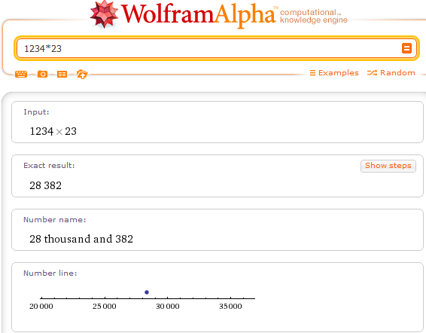

Apart from the result, it gives some extra information too. There’s a lot more to come.

1. Let’s try something more complicated, say Integration

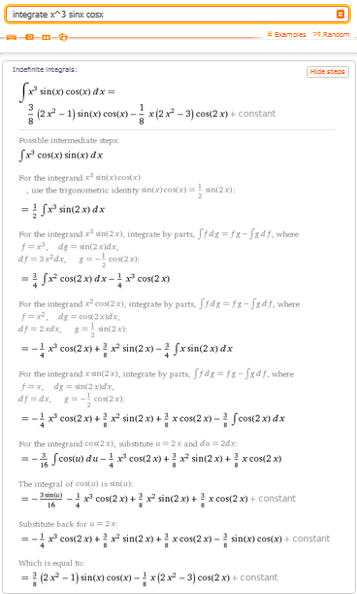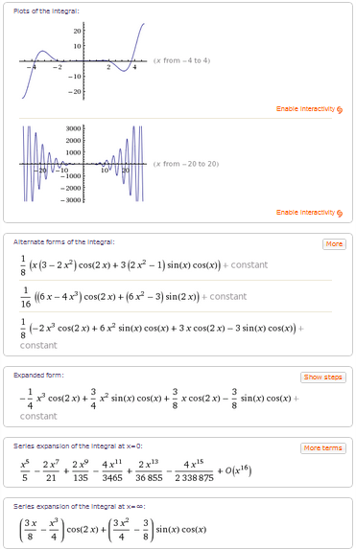

Apart from Calculating an **Indefinite Integral**, it also gives me alternate forms of the answer as well as series expansion at different values. The highlight of this calculation is the ability of showing steps that a person might have followed while arriving to the integral.

It can also solve limits. If my output was “lim(x->2) (x-2)/x” , it would give the correct output of 0.

It also supports an extended keyboard that aids in giving various types of input.

1. Let’s input something close to the real world, say the GDP of India

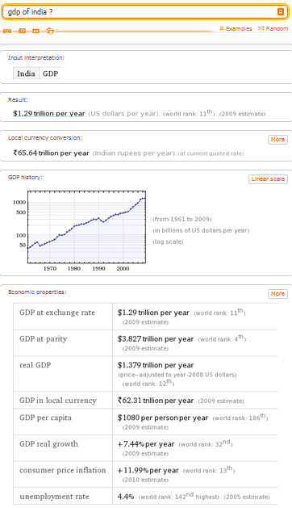

This is where Wolfram|Alpha stands out. Any other search engine would have probably given the accurate GPD of India. But the brilliance of this engine lies in the interpretation of related queries and providing a deluge of data for complete analysis. For example here its giving GPD, world rank, unemployment rate and a graph showing the rise in GDP over the years.

1. Comparison becomes really interesting with Wolfram|Alpha; Let’s compare Microsoft with Apple for example. Instead of getting pages where people have written reviews about the companies or blogs about the same, it uses the data it contains to give the user a complete comparison based on statistics.

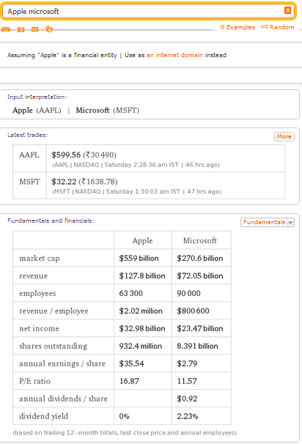

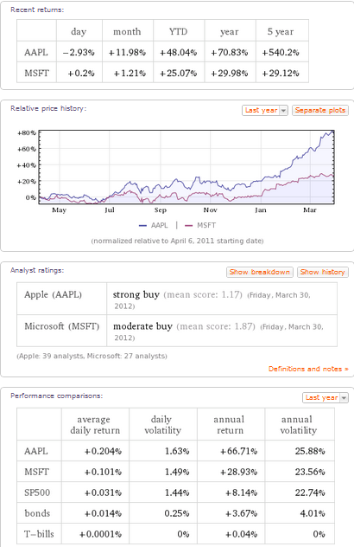

It’s evident that this amount of data will take a larger amount of time to be collected and organized but done brilliantly by Wolfram|Alpha in a matter of seconds.

Also, the answer does not change if input is “Apple vs Microsoft” Or ”Compare Apple Microsoft”.

1. Wolfram|Alpha has weather history of a lot of places. Well, this will convince you of the magnitude of its information database.

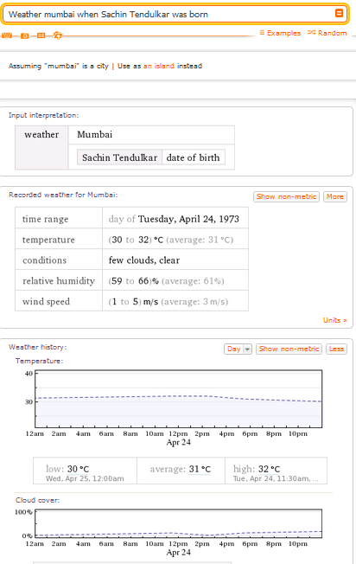

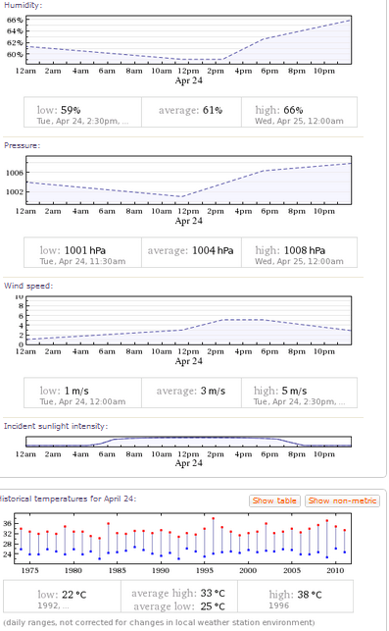

This left me completely enchanted as it not only interpreted that I was searching for the birthdate of a person “Sachin Tendulkar”, but also generated ample amount of data and graphs that would satisfy any sort of curiosity.

1. Wolfram|Alpha doesn’t disappoint on any kind of scientific data as well:

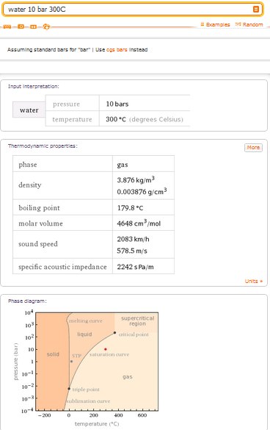

1. Let’s try something totally different: Life expectancy of an average male in India

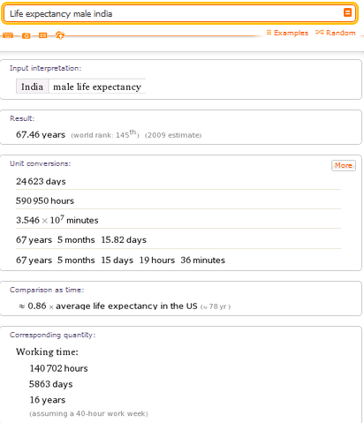

It gives a number along with a few conversions. An interesting data accompanying is that an average Indian male works for 16 years of his life with the assumption taken. Also a comparison with the male expectancy of USA is given.

1. Let’s give an aweful amount of data regarding an exercise:

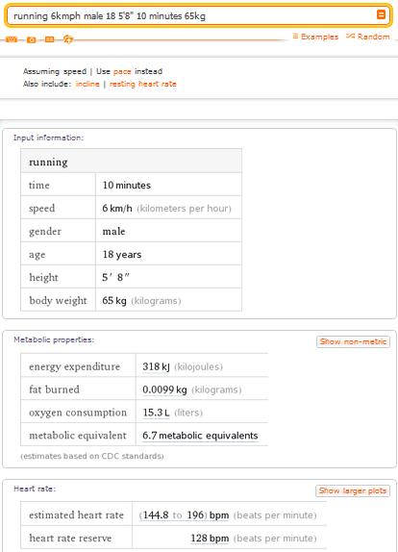

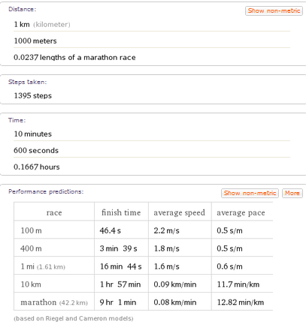

I have just included a portion of the total answer given. By now, you must have realized that the algorithms are robust and the data is enormous. It also predicted the performance in various races according to the data given.

1. Wolfram|Alpha is good as a dictionary too:

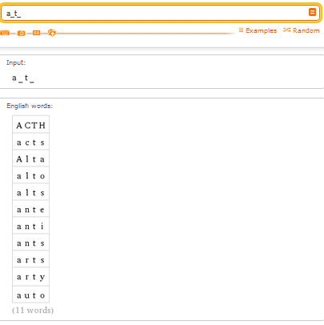

It returned all the 4 letter words having ‘a’ as the 1st alphabet and ‘t’ as the 3rd alphabet.

1. Here’s what it returned when I wanted to know the largest country in Asia

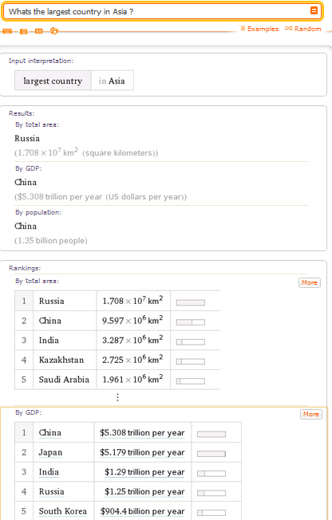

1. Let’s try finding out the Prime minister of India in 2005:

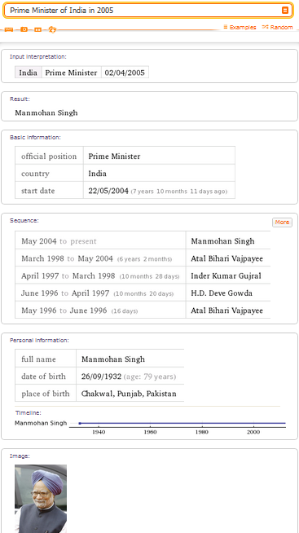

1. It can predict mathematical sequences too, so I entered 4 terms which were of general type (n^n – 1) i.e. 2^2-1, 3^3-1, 4^4-1 as you can see in the screenshot below:



Along with Mean, median and some other data, it gave me what I was looking for at the last:

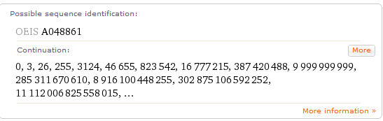

This would choke most calculators of the world and is a total homework killer!

**Some other inputs to try:**

1. If a random name is entered, example “Michael”, it returns all possible information about the name including its rank, graph of age group of people having that name and estimated number of people alive.
2. If a date is entered, it will show with different calculations as to how much time has passed from that date and any significant happening too.
3. If you type ISS – It will surprisingly give you the current position and velocity of the International Space Station.
4. Input of “Mumbai vs New York” would give a complete analysis and comparison of the two cities.
5. Input of “[www.facebook.com](http://www.facebook.com)” would give Site Rank, daily visitors, its location and all sorts of information related to it neatly.
6. “How much did Titanic make?” would give a complete dissection of the earnings of themovie Titanic.

**Shortcomings :**

No doubt, the computations are brilliant; however, sometimes the queries are not understood if it is slightly changed.

For example if the input is “1st largest website”, it gives a list of websites which have ranks on different criterion but if the input is changed to “1st ranked website”, it gives me nothing.

This happens in a few cases. It also cannot (yet) handle queries like “How old was Bill Gates when India got independence?” although it knows date of birth of Bill gates as well as Date of India’s Independence.

**CONCLUSION:**

In the 21st century, when students are expected to use information fluently, this serves as a perfect means to search for specific answers. A Wolfram|Alpha pro version has been released (on February 8,2012) which incorporates additional features like automatic analysis of common file types which you can upload.

Its initial price of a whopping $50 for the iOS has been slashed to $2.99, making this app a must buy. It showed minimal sloppiness with parenthesis and typos, even in mathematical inputs, and guessed what I was looking for very accurately. For example, when I typed “Apple vs Oranges”, it compared the fruits while, typing “Apple vs Microsoft” gave me a comparison of the two corporates.

It makes mathematics look so easy that it seems to be a total homework annihilator. It can breeze through the toughest polynomial and handle the most bizarre calculus and sequences with ease.

Whether you are a mathematics teacher looking for a graph calculator, a scientist/engineer wanting to get hold of formulae, a student desperate to complete homework or someone just looking up facts and figures, Wolfram|Alpha covers it all.

The updates are put up on the blog - <http://blog.wolframalpha.com/> so the users can keep a track of what new kind of queries it can handle.

If it keeps growing as steadily as it has, in accuracy and the amount of data, it will only be a matter of time till we have our Home page set to [www.wolframalpha.com](http://www.wolframalpha.com)!